1. Soil C pool data was calculated from bulk density and organic content% (Table 1, 2, page 170 and 172)

The paper does not report carbon density directly. We calculated carbon density from Table 1 and 2, which reported percent organic matter and bulk density, but not carbon concentration. To calculate carbon density, their data were entered into a spreadsheet, then processed with SAS code to calculate carbon density. The calculation steps were as follows:

a. Convert organic matter (OM) to organic carbon units.

We used the following equation developed by James Holmquist (in review):

SoilCC=0.074*(OM/100)*(OM/100) + 0.421*(OM/100) - 0.0080, where

SoilCC = C concentration in units of grams C per grams soil

OM = organic matter concentration in units of grams OM per grams soil

b. Convert soil carbon concentration (SoilCC) to carbon density.

SC=SoilCC*BD, where

SC=Soil carbon density in units of grams carbon per cubic centimeter (g/cm3)

c. Soil carbon accretion rate (SCrate) was calculated from the soil C and accretion rates from table 2.

SC_rate= SC * Accretion_rate*10000 (SC_rate unit is g C m2 yr-1).

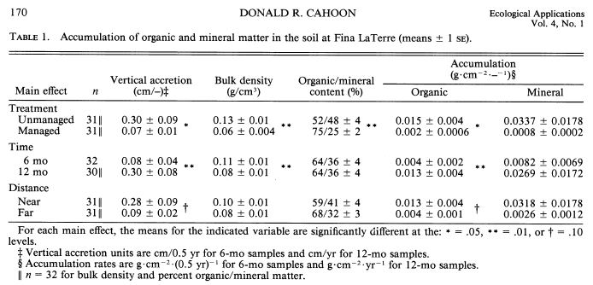

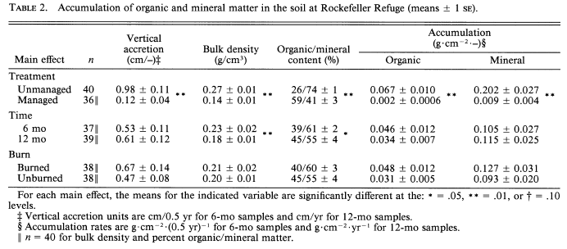

However, Meng was not able to get the number.

***[Response from Blanca]*** *This is the formula for gC/cm3, yes. Update accordingly, even though numbers are almost the same.*